Test Scenario & Test Cases from User Story
TECHNICAL PROJECT REPORT
Submitted to:
Department of IT
Phoenix College of Management and IT
In partial fulfillment of the requirements for the
Extra Course Internal Evaluation
Submitted by
Milan Dahal
BIT 6th Semester
University ID: LC0003002100
2026/08/06

Contents
Introduction 3
Problem Statement 5
Objectives of the Project 6
Requirement Analysis 7
Planning Test 9
Test Implementation 10
Conclusion and Future Improvements 12
References 13
Appendix Error! Bookmark not defined.

Introduction
Software Quality Assurance
Software Quality Assurance (SQA) is simply a way to assure quality in the software. It is a set of activities that ensure processes, procedures as well as standards are suitable for the project and implemented correctly. It is a process that works parallel to Software Development. It focuses on improving the process of development of software so that problems can be prevented before they become major issues. Software Quality Assurance is a kind of Umbrella activity that is applied throughout the software process.
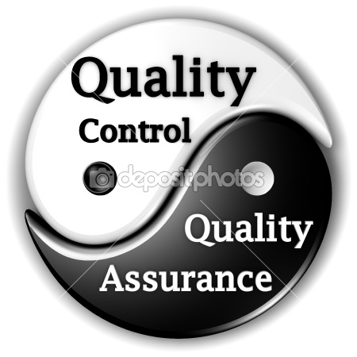
This Photo by Unknown Author is licensed under CC BY

Quality Control (QC) is the process of checking products or services to ensure they meet set standards and are free from defects. It involves inspecting and testing different stages of production to identify and fix problems. By doing this, QC helps maintain consistency, improve customer satisfaction, and ensure that the final output is reliable and meets expectations.
Importance of Software Testing in Software Development
Software Testing checks whether a software application works correctly and meets its requirements. It helps ensure the software is reliable, functional, and ready for users.
- Identifies bugs and errors
- Validates functionality
- Ensures performance
- Improves overall quality
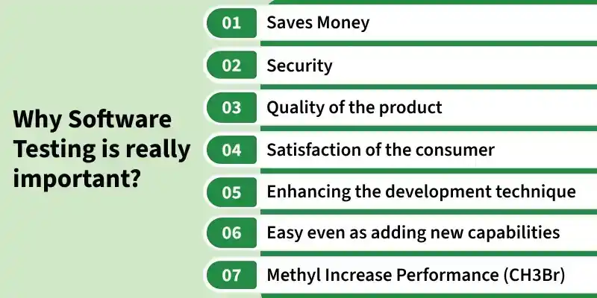

Purpose of the Project
The purpose of this project is to apply the knowledge of software quality assurance by designing test scenarios and test cases based on given user stories. The project focuses on four important features of an e-commerce website: Product Search, Guest Checkout, Verified Customer Reviews, and Save to Wishlist. Through this project, the student practices converting user requirements into clear, complete, and measurable test cases using Microsoft Excel.

Problem Statement
- Description of the Software/Application Under Test
The application under test is an e-commerce website that allows users to browse products, search for items, add products to a shopping cart, complete purchases, write reviews, and save items to a Wishlist. The system supports both registered users and guest users. Key features covered in this project include product search with filters, guest checkout options, verified customer reviews, and Wishlist functionality.

- Scope of Testing
The scope of this project is limited to the design of test scenarios and test cases for the four given user stories. The activities performed include:
- Understanding and analyzing the user stories
- Identifying testable conditions from each user story
- Creating 14 test scenarios
- Writing 38 detailed test cases in Microsoft Excel
- Planning the types of testing that would be suitable for these features
Actual test execution was not performed as part of this project. The focus remained on test design and documentation.

- Objectives of Quality Assurance
- To ensure that all acceptance criteria in the user stories are covered by test cases
- To create clear and reusable test documentation
- To apply standard testing techniques such as positive testing, negative testing, and boundary value analysis where applicable
- To gain practical experience in writing professional test artifacts

Objectives of the Project
- Learning Objectives
- To understand how user stories are used as requirements in Agile projects
- To learn the process of converting user stories into test scenarios and test cases
- To practice writing clear, complete, and traceable test cases
- To gain familiarity with standard test documentation practices used in the industry

- Testing Objectives
- To design test scenarios that fully cover the four given user stories
- To create detailed test cases covering positive, negative, and edge conditions
- To ensure that each acceptance criterion is linked to one or more test cases
- To prepare test documentation that can be used for future test execution

- Expected Outcomes
- A complete set of 14 test scenarios covering all four user stories
- 38 well-structured test cases documented in Microsoft Excel
- Improved understanding of software testing concepts and documentation standards
- A professional technical report summarizing the entire process

Requirement Analysis
Functional Requirements
User Story 1 – Product Search:
- Users can type keywords in a search bar available on any page and view relevant products.
- Users can filter search results by price range, category, and average rating.
- When no products match the search, a clear “No results found” message is displayed.
User Story 2 – Guest Checkout Option:
- Users can select “Checkout as Guest” without logging in or registering.
- Guest users can complete a purchase by providing email, shipping address, and payment details.
- An order confirmation and digital receipt are sent to the provided email address.
User Story 3 – Verified Customer Reviews:
- Logged-in users who have purchased a product can submit a 1–5-star rating and written review.
- Average star rating and total number of reviews are displayed near the product title.
- Users who have not purchased the product cannot leave a review and see an appropriate message.
User Story 4 – Save to Wishlist:
- Logged-in users can save a product to their Wishlist using a heart or “Add to Wishlist” icon.
- Users can view all saved items and their current prices on a dedicated Wishlist page.
- Users can move items from the Wishlist to the shopping cart using a “Move to Cart” button.
Non-Functional Requirements
- Usability: The search bar, filters, and Wishlist icons should be easy to find and use.
- Performance: Search results and filters should be loaded within a reasonable time.
- Security: Guest checkout and payment information must be handled securely.
- Compatibility: The features should work correctly on Google Chrome browser.

Assumptions and Constraints
Assumptions:
- The e-commerce website has a working user registration and login system.
- Product data, categories, prices, and ratings already exist in the system.
- Email delivery service is available for sending order confirmations.

Constraints:
- Only manual test design was performed; no actual execution was done.
- Testing is limited to Google Chrome browser.
- Time and resources were limited to the scope of the academic assignment.

Planning Test
Test Strategy
The test strategy for this project is requirement-based testing. Each user story and its acceptance criteria were carefully analyzed. Test scenarios were first identified at a high level and then detailed test cases were written to cover positive paths, negative paths, and important edge conditions. The goal was to achieve maximum coverage of the given requirements through well-designed test cases.
Test Plan
- Review and understand all four user stories.
- Identify testable conditions and acceptance criteria.
- Create test scenarios for each user’s story.
- Design detailed test cases in Microsoft Excel with proper columns (Test Case ID, Scenario, Steps, Expected Result, etc.).
- Review the test cases for completeness and clarity.
- Document the entire process in a technical report.

Test Environment
Since actual execution was not performed, the planned test environment is as follows:
- Browser: Google Chrome (latest stable version)
- Operating System: Windows / macOS / Linux
- Tools: Microsoft Excel for test case documentation
- Test Data: Sample product data, valid and invalid email addresses, sample shipping details, and test payment information

Test Implementation
Test Scenarios
A total of 14 test scenarios were created to cover all acceptance criteria from the four user stories. The scenarios were grouped as follows:
Product Search (Story 1):
- Successful product search using valid keywords
- Filtering search results by price, category, and rating
- Display of “No results found” message for invalid or unmatched search terms

Guest Checkout (Story 2):
- Selecting “Checkout as Guest” option from the cart
- Completing purchase with valid guest details
- Receiving order confirmation email after successful guest checkout

Verified Customer Reviews (Story 3):
- Submitting a valid review by a verified purchaser
- Viewing average rating and total review count on product page
- Restriction for users who have not purchased the product

Save to Wishlist (Story 4):
- Adding a product to Wishlist using the heart icon
- Viewing saved items and current prices on the Wishlist page
- Moving an item from Wishlist to the shopping cart
Test Cases Design
A total of 38 test cases were designed and documented in Microsoft Excel. Each test case includes the following fields:
- Test Scenario ID (unique identifier)
- Test Scenario Description
- Test Case ID
- Test Case Description
- Pre-conditions
- Detailed Test Steps
- Test Data
- Expected Result
- Actual Result and Status (to be filled during future execution)

Test Data Preparation
Sample test data was planned for future execution. Examples include valid product keywords, different price ranges, valid and invalid email addresses, sample shipping addresses, 1–5-star ratings, and review texts of different lengths.
Manual Testing process
The planned manual testing process would involve executing each test case step by step in Google Chrome, comparing the actual result with the expected result, and marking the status as Pass or Fail. Any defects found would be documented with severity and steps to reproduce. However, this step was not carried out in the current project phase.
Challenges Faced During Testing
- Understanding the exact expected behavior when some details were not fully specified in the user stories.
- Deciding the right level of detail for test steps so that the cases remain clear but not overly long.
- Organizing many test cases in Excel in a clean and maintainable way.
Lessons Learned and Skills Developed
- Ability to analyze user stories and extract testable conditions
- Skill in writing clear and structured test cases
- Understanding of different types of testing and when to apply them
- Improved documentation and professional report writing skills

Conclusion and Future Improvements
Overall Testing Outcome
This project successfully achieved its main goal of designing comprehensive test scenarios and test cases based on four important e-commerce user stories. A total of 14 test scenarios and 38 test cases were created and documented professionally in Microsoft Excel. The work demonstrates a solid understanding of requirement analysis and test design techniques.
Future Testing Enhancements
In future phases, the following improvements can be made:
- Execute all 38 test cases and record actual results and defects.
- Expand test coverage to include more edge cases and boundary values.
- Perform cross-browser testing on Firefox, Safari, and Edge.
- Add mobile responsiveness testing for the same features.
Continuous Integration / Continuous Testing Possibilities
In a real project environment, the test cases designed in this project can be automated using tools such as Selenium, Cypress, or Playwright. These automated tests can then be integrated into a Continuous Integration (CI) pipeline so that they run automatically whenever new code is committed. This approach supports Continuous Testing and helps maintain high software quality throughout the development lifecycle

References
1. ISTQB Foundation Level Syllabus. International Software Testing Qualifications Board.
2. Software Testing Help. Online resources on test case design and software testing techniques. Available at: https://www.softwaretestinghelp.com
3. Microsoft Excel Documentation. Microsoft Corporation.
4. BrowserStack Testing Guides. Available at: https://www.browserstack.com/guide
5. Agile Alliance. User Stories – An Agile Introduction. Available at: https://www.agilealliance.org
6. Selenium Documentation. Available at: https://www.selenium.dev/documentation
7. Playwright Documentation. Available at: https://playwright.dev
8. GeeksforGeeks. Available at: https://www.geeksforgeeks.org/software-testing/why-software-testing-is-important/

